 | Final Product | Stitches Taught | Fabric Manipulation/ Fastenings/ Embellishments | Cutting Fabric | Visual | Any Other Notes
EYFS | - Experiences of weaving in a variety of contexts.  - Threading as a skill
Y1 | Sock Puppet | Running Stitch  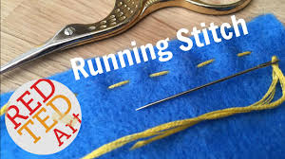 | Applique  Fabric Pens | Cutting scraps to the desired size. | 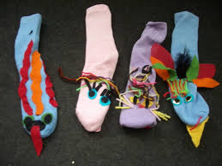
Y2 | Finger Puppet | Over Stitch  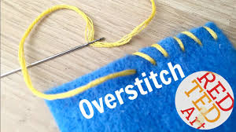 | Applique  Fabric Paint | Using a template to draw around and cut out.  (Some may need support) | 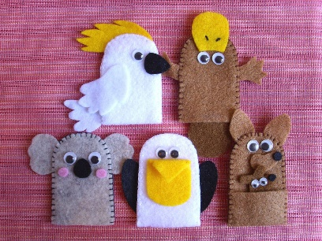
Y3 | Purse | Blanket Stitch  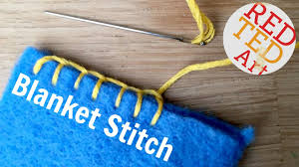  (Can be substituted for overstitch for those struggling) | Button  Printing | Using a template to draw around and cut out..  Marking where the button hole will go. | 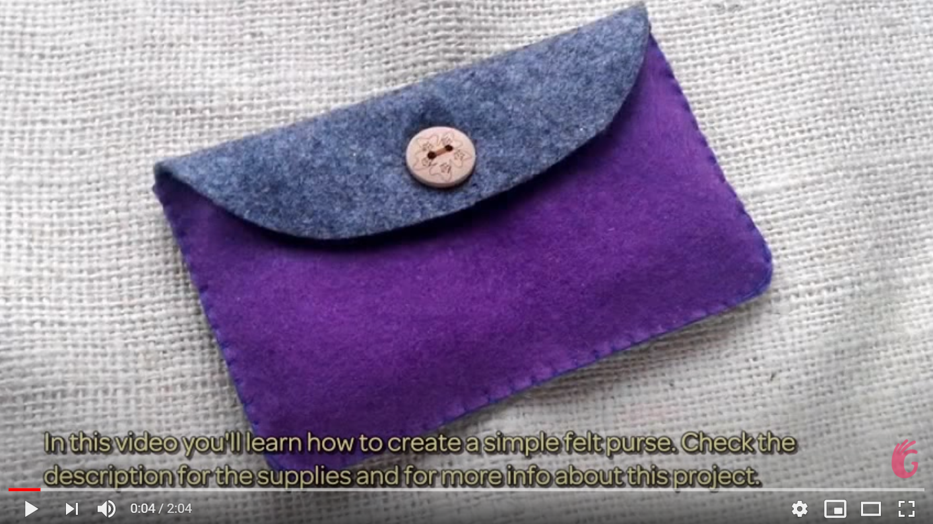  https://www.youtube.com/watch?v=9RfGObSTAf0
Y4 | Bag | Back Stitch  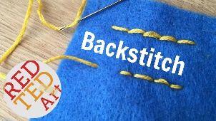  (Can be substituted for a tight, short running stitch for those struggling). | Tie Die | Cutting and organising multiple pieces.  Some can draft own pattern from given dimensions. Others may need a pattern piece. | 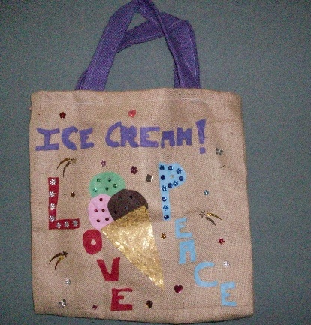 | Key Figure/Event: David Attenbrough and the reduction of plastic bags.
Y5 (and Rowan) | Full Puppet | 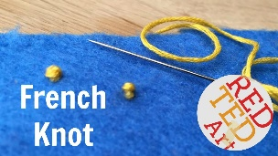  Great for adding eyes! | Applique  Decorative Stitches | Drafting own shapes and shapes of specific applique to be added. | 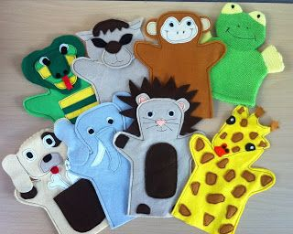  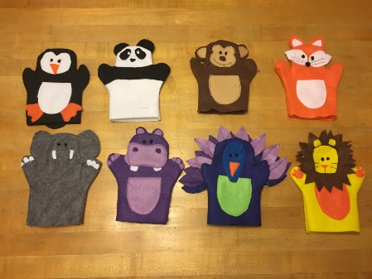
Y6 | Phone Case | Combination of all of the above. | Button  Key Ring  Velcro  (A selection for children to choose from)  Batik | Children to draft pattern from their own phone specifications, measuring accurately and understanding that the phone will occupy that space, so the 3D shape must be accomodated for. | 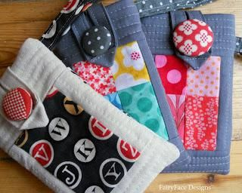  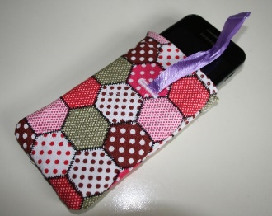  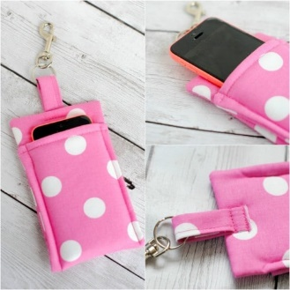
Stitch Videos: https://www.redtedart.com/basic-hand-stitches-beginners/
EY- Weaving and threading.

